Tutorial 4 Answers – Chris Dworczyk

# Part A

Q: Make use of referenced and online resources to produce two examples each of executable programming codes in C# environment for implementing Static and Dynamic memory allocation.

## Static

## Dynamic

# Part B

Q: Write a short note on each to discuss the likely causes and how to detect/fix the problems.

* Memory Leak
  + Memory leaks happen when old unused data in heap memory doesn’t get disposed of correctly which leads to performance issues and failure.
  + To avoid such problems the programmer should make use of the free(); line to free up memory that doesn’t get used anymore.
* Dangling pointer
  + A dangling pointer occurs when the data in memory where the pointer is pointing gets deallocated or deleted leaving the pointer still pointing at the location.
  + 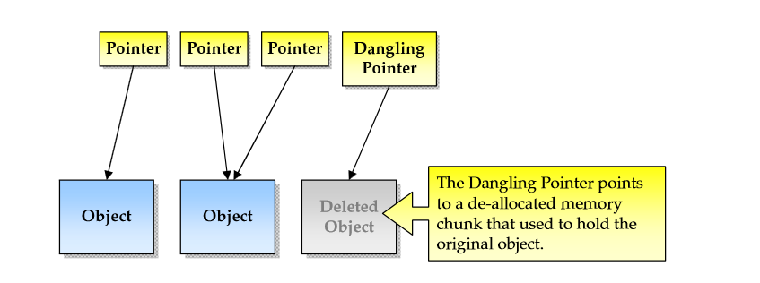
* Memory fragmentation
  + Memory fragmentation is when most of your memory is allocated in a large number of non-contiguous blocks, or chunks - leaving a good percentage of your total memory unallocated, but unusable for most typical scenarios. This results in out of memory exceptions, or allocation errors.
  + 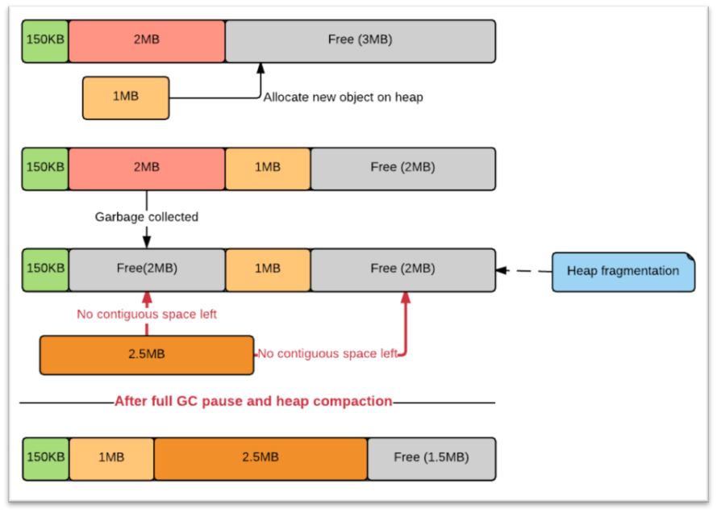
* Memory de-allocation